Celebrate God’s Harvest:
Bring your Minister to Work to see your Harvest
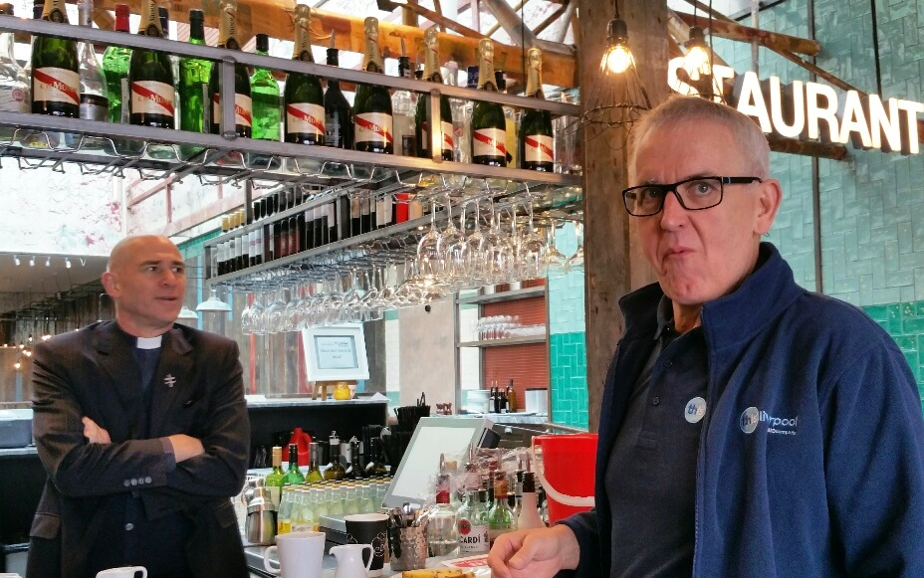

You minister knows you… but do they know about your work?...
Why not invite your Church Minister to visit you at work this Autumn?
During the visit you might like to talk about:
- How experiences at work have changed your life.. and your faith?
- How you have discovered moments of God’s love in the workplace?
- How you handle regrets and grief at work?
- How you manage life goals alongside what you are striving for at work?
- What do you need prayer for at work?
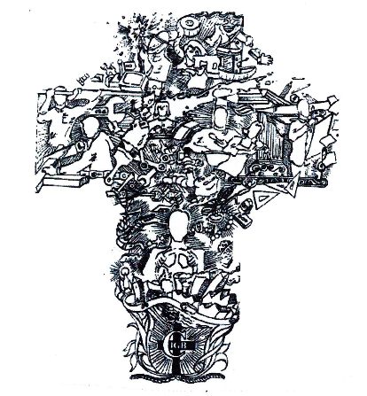
Pope Francis says that work (in all forms) is an essential part of what it is to be a Child of God: “Work is part of God's loving plan, we are called to cultivate and care for all the goods of creation and in this way participate in the work of creation! Work is fundamental to the dignity of a person..”
Genesis (1:26; 2:5; 2:15) describes God’s call to us to work and to contribute to God’s creative purposes – even though our work often falls short of the ideal.
Work is a spiritual activity. At Harvest lets rejoice in the fruit of our work together with God.
“Let us Sing of God’s Love At Work”
www.cigb.org.uk

